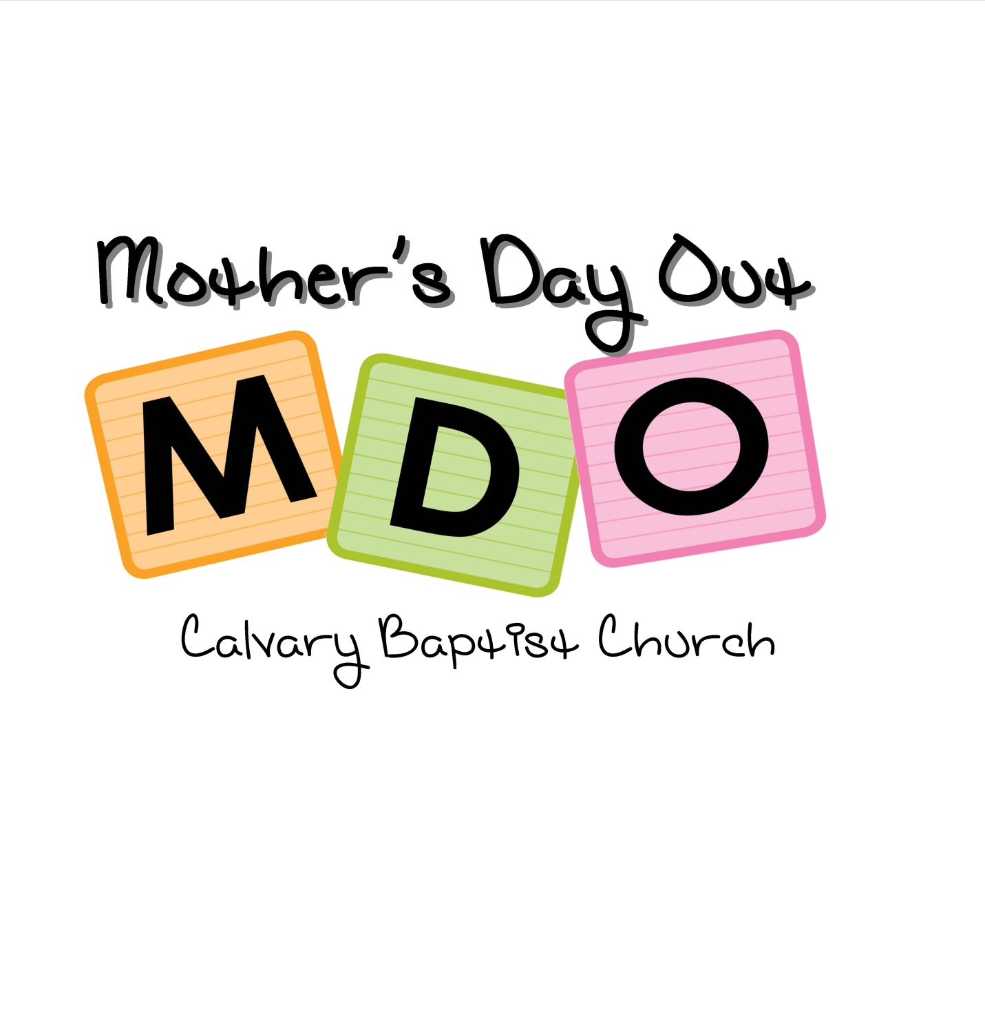

Handbook

Dear Parents:

Welcome to Calvary Baptist Church Mother’s Day Out program. Our program was created to provide your child with a safe place to grow spiritually and loving environment where he/she may begin learning independence and interactive play while forming new friendships with other children. Our staff desires to lay a foundation that will guide your child into a love for God, a love for others, and a love for learning. It is our goal to make MDO a fun and happy place that your child will anxiously anticipate each week.

This handbook is designed to help you better understand our program and our guidelines. We believe God commands us to “train up a child in the way he should go so when he grows old, he will not depart from it” and we desire to partner with you in this mission.

Thank you for allowing us the privilege of serving you and your child!

In Christ,
Maryellen Hutchinson
MDO Director

Mission Statement
Our Mother’s Day Out Program was created to teach your child about Jesus and give him or her a safe place to grow spiritually, socially, and physically. We want to lay a solid foundation in the Bible that will lead to a love for God, for others, and for learning. We believe children are a blessing from the Lord and treat each child as a special gift from Him.

Admissions
- All children must be enrolled by a parent or legal guardian who agrees to be responsible for their behavior and financial obligation.
- No child will be denied entrance into the MDO program on the basis of race, color, gender, or creed.
- All children will be required to submit a vaccine record to the MDO Director prior to August 1, 2017.
- To enter the Pre-K Class, a child must be 4 years old by August 1, 2017
- To enter the Older Toddler Class, a child must be 2 years old by August 1, 2017
- To enter the Young Toddler Class, a child must be 1 year old by August 1, 2017
- To enter the Infant Class, a child must be 6 months of age by August 1, 2017

Classes
- Pre-K Class– 4 and 5 year olds
- Older Toddler Class – 2 and 3 year olds
- Young Toddler Class – 1 year olds
- Infant – 6 months and up
*Class size is limited and based on those who turn in their registration fee first.
*Our classes may be split into smaller age ranges, based on enrollment.

Fees and Monthly Tuition
Two day a week program (Tuesdays and Thursdays)
Tuition: $165 per month
**$155 for Calvary Baptist Church members

Registration fee - $100 (non-refundable) – covers enrollment cost, snacks, and supplies
(This is required to hold a place for your child. Enrollment is based on availability for each age group.)

One day a week program (Tuesdays): *Infant and toddler classes ONLY
Tuition: $100 per month
**$90 for Calvary Baptist Church members

Registration fee: $85 (non-refundable) – covers enrollment cost, snacks, and supplies
(This is required to hold a place for your child. Enrollment is based on availability for each age group.)

Tuition is due on the first of each month. All accounts must be kept current! After the 10th of each month a $10 late fee will be charged. If tuition is not paid by the 15th, a letter will be sent home stating the child may not attend until the account is current and a child’s place can be lost in the classroom.

Tuition payments may be paid to the Director or church secretary in the church office. Please do not give payments to teachers to ensure there are no lost payments or miscommunications.
Checks may be paid to Calvary Baptist Church. Please put your child’s name in the memo line.

Attendance
Regular class attendance is very important to your child and to the class. It is important for each child to be present at the beginning of the day so they can begin with their other classmates and not miss out on any activities. If your child will be late or must leave early, please notify the church office or your child’s teacher.

Arrival and Departure
Children must be walked into the building and accompanied to their classroom. Please do not allow your children to walk to their classroom alone. Drop off time is at 9:00am. Please do not bring your child earlier as teachers will be participating in staff prayer time and preparations for the day. Your classroom teacher will open her door promptly at 9:00 to welcome the children. The parent or guardian is required to sign in and out their child every day at the child’s classroom door. The signing in and out of your child is an important safety feature. Our teachers use this sign in sheet as their reference sheet when we have emergencies, fire drills, and any unexpected weather related issues that require us moving the entire student body to safety.

**We want MDO to be a happy time for your child. It is best to offer your child a quick hug or goodbye, rather than a prolonged farewell. Remember—your child is in good hands...go and have a great day!!!

At dismissal, you must sign your child out at his/her classroom. If you wish to pick up early, please let your child's teacher know ahead of time. Please do not allow your child to walk alone or run ahead through the hallway.

Please be prompt in picking up your child from MDO. A fee will be charged for any child remaining after 2:05. A late fee of $1.00 per minute will be charged every minute after 2:05 pm as our teachers are only being paid during the operating hours. It is simply not fair to them or to your child who may become anxious as all their classmates have left and they may feel they have been forgotten. Charged slips will be sent home the same day and payable within 24 hours.

Children will only be released to the child’s parents or those listed on your child’s emergency contact list.

If a child is to be picked up by someone other than his/her parent or emergency contacts, please submit that in writing to your classroom teacher! A child will NOT be released to someone else unless the classroom teacher has received permission in writing prior to dismissal.

**NO RUNNING VEHICLE MAY BE LEFT UNATTENDED ON THE PREMISES.

A Note About Your Child & Separation Anxiety
During these infant and preschool years, it is normal for children to show signs of separation anxiety, which is the most common fear in children. Typically beginning about 9 months through age 2, many children begin to exhibit signs of separation anxiety if left for any period of time with others or even another parent. Some children, who have not been exposed to the full-time daycare environment, may become anxious, cry, or be upset when left. This is common for the first couple of days a child attends a MDO program. We assure you that we will care, love, and reassure your child. You will be notified if you child does not calm down within 15 minutes.
The following are just suggestions that could help.
• Stand your ground. Make sure your child knows they will be all right while you are gone.
Try to settle them in the environment with the teacher before leaving, and
then leave.
• Leave after reassuring and goodbyes. (Lingering around and/or staying in the
classroom will only prolong the situation). Hand your child over to the teacher
and know he or she is in good hands.
• Compliment your child’s brave behavior.
• Talk to your child about what is going to happen beforehand. Spend some time talking
to your child about what to expect, assuring them that you will return.
• Establish a ritual. When leaving, try to do the same things every day such as a hug,
kiss, and saying, “See you later, alligator!”
• Push the positives. Talk to your child about the fun things that happen at MDO such as
story time, lunch with friends, recess, snack time, art, etc.
• Make sure your child gets enough rest. If tired, your child may be cranky and even
clingy.
• Know the crying will stop. Most of the crying stops within minutes of the parent leaving,
so take comfort in that reality. Teachers are trained to engage your child in a fun
activity or to begin playing with friends.
• Take perspective. Give your newly established routine two weeks. Most children will
have adjusted in that amount of time and find they love playing with new friends,
new activities and love their teacher. The separation can be harder on you than
on your child, but short periods away from your child will leave you feeling more
refreshed and balanced. Enjoy your time!

Teaching Staff
Our teachers are committed to sharing Christ’s love with each child in our care and exhibit His love and devotion to Him in all areas of life. They share in the heart of this ministry to love and care for the child and family. As our program grows, additional teachers may be hired or moved into different classrooms to accommodate changing needs. Parents will be kept up to date on all changes and should know with confidence that only the very best are placed in teaching positions.

Calendar
Our program will follow Warren County School calendar with the exception of the beginning and end of the school year. When the Warren County schools are closed due to inclement weather or professional development, we are also closed. If the county schools dismiss early, we dismiss early as well. You may tune into our local television station WBKO or log onto their web site for the Polar Report when you are in question.

**First Day – August 22, 2017
**Closed – April 26, 2018
**Last Day – May 10, 2018
**exceptions to Warren County Calendar

Visitation
Parents are VERY welcome to visit. Contact the MDO Director or your classroom teacher to coordinate your visit.

Communication
We strive to work with your family to love and teach your child. Please feel free to talk with your child’s teacher or the Director if you have any concerns or comments. If you would like to talk with your child’s teacher or the Director, we do ask that you schedule a time as to not interrupt the other children’s learning and for our staff to be able to offer you their undivided attention. Staff members may not be able to meet after our program dismisses if they have not been given advanced notice.

A class communication record will be sent home with your child each day to inform you of your child’s activities and conduct for the day. Please be sure to check these after each MDO.

Discipline
Our main objective is to love your child as Jesus does. Our discipline will be positive and will encourage children to make good choices and learn self-control. Aggressive or disruptive behavior must not be overlooked because it sends a message to the other students in our care that this behavior is acceptable. A child needs to know that it is never “okay” to hurt another child or adult. If at any time the MDO staff observes behavior that puts the child, another child or the staff’s physical safety or well-being in jeopardy, MDO reserves the right to remove that child from the program. The process of discipline is to help teach children appropriate ways to meet their needs and to stop inappropriate behavior.

Our MDO program has three rules each class follows.
1. Be Kind
2. Be Safe
3. Be Respectful

We will use the first few weeks of our program to teach our children our rules and expectations. In the older classes, we will use a color system to monitor students’ behaviors. Children will begin their day on green (great). If a student misbehaves, he or she will move to yellow (warning) and receive a private verbal warning and redirection from their teacher. If the student continues to disobey, he or she will move to orange. The students will receive a short time-out from the activity. If a student does not improve their behavior, the student will move to red. The student will receive another time-out and a parent will be notified of their behavior. Our teachers will also use positive reinforcement to praise behaviors that are appropriate.

Time-out will only be used for children - 1 minute for their age (i.e. 2 minutes for 2 year olds, 3 minutes for 3 year olds). During a time-out, children will discuss with their teacher their behavior and ways to make better choices. Children will not be isolated to a corner but instead re-directed and given time to calm down then re-engage in activities with the class.

Our staff focuses on disciplining with consistency and love. Our goal is to teach students acceptable behavior in order for them to learn self-control, which will lead to a positive learning environment.

Should a child demonstrate a more aggressive or disruptive behavior the parent will be contacted, and the MDO staff will work together with the parent to solve the problem.

If you do have any concerns about your child, please feel free to talk with the teacher or the director. We will refrain from talking about the child in their presence, but will be happy to coordinate a time to discuss any issues.

Withdrawal
Two-week notice in writing is required for withdrawal and should be submitted to the program director. Our program is unable to reimburse for partial months attended.

Pets and Other Animals
In order to maintain a safe environment for all children, we do not allow animals of any kind in our building.

Schedule
Each class will maintain a guideline of daily activities so the day runs smoothly. Your child will grow to appreciate the routine and predictability.

Rest Time
All classes will have rest/quiet time. Please send a kinder mat and/or blanket to school with your child for the Older Toddler and Pre-K class. The blanket must be able to fit in your child’s backpack/bag and travel home with your child each day. Please ensure each item is clearly marked with your child’s name. Children will be required to rest on their nap mats for the allotted time. They are not required to sleep. A quiet activity may be provided while others sleep. Cribs are provided for infants and young toddlers.

Snacks
A small snack will be provided in the morning to our classes. Please let your classroom teacher know of any allergies!! We ask that you send the appropriate food and feeding schedules for children in the infant classes. If you wish for your infant to participate in the morning snack during MDO, please let your child’s teacher know.

Lunch
Children are to bring their own nutritious lunch. It should be finger foods or easy to eat items that do not need to be microwaved or refrigerated. Infants are an exception to this guideline. If your child drinks everything you’ve sent with them for the day, water will refill their cup, unless otherwise noted. Please label lunch boxes, sacks, and thermoses / cups. Please provide milk, juice, or water for your child (no carbonated beverages please). Send required utensils or plastic disposable when necessary. Candy is not allowed! Hot dogs and Vienna sausages need to be cut length-wise and then into small pieces. This applies to all age groups.
If your child has a food allergy, please inform his/her teacher!

Clothing
Please send your child in comfortable, washable, and season appropriate clothing and outerwear. Please dress your child in easy to pull up and down pants. Send a coat or sweater when needed so your child will be able to participate in any outdoor activities we may have. Please label all of your child’s items…jackets, gloves, hats, extra clothing. A change of clothing including underwear and socks will be needed in case of any accidents. This extra set of clothing should be sent in your child’s backpack each day. For children in diapers or pull-ups, bring extra disposable diapers or training pants. For your child’s safety, open toe shoes and those that are not secure to the foot are prohibited. This would include flip-flops and “Crocs”.

Potty Training
Our teachers will assist children as needed in their toileting needs. For those currently being potty trained, please share with the teacher special needs and requests. All efforts will be made to aid in the potty training process. We do ask that those that are not completely potty trained to wear pull-ups and send an extra change of clothes that can be kept in their bag.

Personal Items
Please keep your child’s personal toys at home. This will prevent items that might become lost or broken. If a security item is needed during naptime, please limit it to only one item. Please also label all items brought to MDO.

Supplies
The MDO Director will advise you of requested supplies before your child’s first day (i.e. wipes, construction paper, crayons, glue, paint, & etc.) These supplies aid in classroom management, crafts, and games. They also aid in keeping tuition costs at an affordable price.

Backpacks/Bag
Each child should bring a standard-size backpack or bag with them to class.

Each backpack/bag should have:
• The child's name printed on the outside top or front. (Either directly on the backpack
or on tape).
• Full change of seasonal appropriate clothes at all times, including socks and
underwear.

Please place these items in a clear plastic zip lock bag with the child’s name clearly labeled.
• Lunchbox
• Diapers, wipes and/or anything your child might need throughout the day.

Birthday Policy
Birthdays are very special, especially to children. If you would like to celebrate your child’s birthday during MDO, please contact your child’s teacher the week before you wish to celebrate. You are welcome to bring store-brought items to distribute during lunch (example: big chocolate chip cookie, cupcakes, juice boxes, &c.). Due to health regulations, we ask that you do not bring homemade food items to distribute. Please arrange all details with the classroom teacher.

Our MDO Program is only able to distribute birthday invitations if every student in the class is invited. This is in an effort to protect the feelings of ALL of our students.

Health and Safety
**A current Kentucky certificate of immunization is required before your child enters the program. These can be obtained from your child’s physician or the Health Department.
Note the expiration date on the card and return new cards to the office as necessary.

**Medication— No medicines shall be given by the staff to the children except with a signed and dated request from the parents. The medicine must be in the original container and clearly labeled with the child’s name, name of drug, and directions for administering. Over the counter drugs must have the amount of the dosage for the age of the child on the container, otherwise we cannot give it to the child regardless of parent permission. If a child has an epi-pen, we still need a signed and dated request that we will keep in the child’s room at all times.

**Sunscreen —If you wish for your child to have on sunscreen, please apply before they come to school. We recommend applying sunscreen on warm, sunny days as we will be outside when weather permits.

**Accidental Injuries—You will be notified immediately if there is an injury. In case of an emergency, 911 will be called. If we are unable to reach the parents/guardian, we will notify the person/s listed on your registration form. Please inform us of any changes that need to be made on this form throughout the year. We will document all injuries and the classroom teacher and parent will sign an accident report.

The program exercises reasonable care and judgment in all matters related to safety. In all emergencies, the program has permission to take such reasonable measures, in the judgment of the teacher, director, or pastor, necessary for the welfare and safety of the child until a parent can be reached. Our staff will administer first aid consisting of cleaning small wounds and applying ice when necessary unless otherwise advised by the parent.

Illness
—If your child is ill, please keep him/her home from MDO. In order to keep our classes "healthy", we ask you to please keep your child home if he/she has had any of the following:
- Fever (must be free of fever for 24 hours before returning)
- Vomiting and/or diarrhea (must be free of vomiting and/or diarrhea for 24 hours)
- Any symptoms of childhood diseases such as
  - Whooping Cough
  - Scarlet Fever
  - Measles
  - Chicken Pox - all sores must be scabbed over and dry at the edges before returning
  - Strep throat
  - Flu
  - or any other infectious disease
- Common cold—from the onset through one week!
- Sore throat
- Croup
- Fifth Disease
- Unexplained rash
- Head Lice
- Any skin infection—Boils, Ringworm, Impetigo, Thrush, Hand-Foot-Mouth disease
- Pinkeye and/or any other eye infection
- Cloudy or green runny nose
- Persistent cough
- Mononucleosis
- Severe allergies

Your child is to be symptom free or cleared by a doctor 24 hours prior to returning to MDO. For example, if your child experienced symptoms of a stomach bug during the weekend and stopped having symptoms Monday at noon, your child will not be allowed to return until noon on Tuesday.

Check with your physician for diagnosis, treatment, and the proper time for returning to school.
If a child becomes sick at school, he or she will be cared for in an isolated area. Parents will be notified and required to take the child home immediately. Please be sure to write a number where you can be reached on the sign in sheet each day for situations just like these. It is very important that you keep your cell phone on when your child is in our care.

Parent Agreement—Handbook

I,____________________________, whose child ____________________________
(print your name) (print your child's name)

is enrolled in the 2017-2018 school year of Calvary Baptist Church Mother’s Day Out Program,
have received a copy of the Parent’s Handbook. I have read and understand the policies and guidelines
as described in the handbook, and I agree to abide by them.

__________________________________ ____________________
(Signature of Parent/Guardian) (Date)

Photograph/Video Release and Authorization
The undersigned hereby authorize Calvary Baptist Church MDO program, its staff/or employees, to photograph and/or film me and/or my child, and consent to the use of my and/or my child’s likeness in any and all publications and/or materials, including, but not limited to, advertising, news media, video and website materials. I further release Calvary Baptist Church from and waive any rights that I and/or my child might have to any revenue payment or fee for said photography and/or film.

__________________________________ __________________
(Signature of Parent/Guardian) (Date)

PLEASE PRINT, SIGN, & RETURN THIS PAGE WITH YOUR REGISTRATION

